Mond Valley Community Golf Club

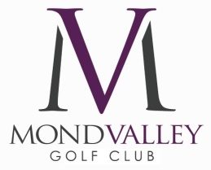

Mond Valley Golf Club Insurance Policy

Mond Valley Golf Club endeavours to provide facilities to its members and guests, however, Mond Valley Golf club cannot accept responsibility for any loss or damage to members or visitors property however caused.

Whilst we do have a comprehensive insurance provision aimed at providing cover for Public and Employers liability, Personal Accident, buildings, equipment, fixtures and fittings etc., members should not rely on the limited provisions of the policy when seeking to cover their own property.

Members are strongly advised that they should make their own measures to cover the full replacement value of their property when at Mond Valley Golf Club and set an appropriate excess

Management Board

