Mond Valley Golf Club

Handbook for CompetitionRules and Handicaps

CONTENTS
1 Suspension of Play Abandonment of Competition Page 3
2 Club Competitions Page 4
2.1 Competition Calendar
2.2Qualifying and Non Qualifying Competition
3 Entry Procedures for Club Competitions Page 6
3.1Tee Times Starting Sheets
3.2 Reservation of TeeTimes
3.3 Playing Arrangements
3.4 Scorecards -Marking and recording scores returned
3.5 Resolution of Ties
3.6 Notification of Competition Result and Prizes
3.7Disqualification and Breaches of Competition Rule3
4 Club Knockout (Matchplay)Competitions Page 8
4.1 C.C. CUP -SinglesMatchplayCompetition
4.1.1 SENIORS-Singles Matchplay Competition
4.1.2 JACK LEWIS CUP-PairsMatchplayCompetition
4.1.3SENIORS CUP -PairsMatchplay Competition
4.1.4 CHARLESON CUP - Mens Scratch Matchplay
4.2 Rules and Eligibility of Entry to Knockout Competitions
4.3Procedures for Contacting Opponents
4.4 Disqualification from Competition

5 Procedures for Withdrawing from Competitions Page 10
5.1 Failure to Appear on the Tee
5.1.1Individual Competition
5.1.2 Pairs Competition
5.1.3 Booking and Cancellation of Tee Times

6Handicaps Page11
6.1 Management of Handicaps
6.2 Obtaining a WHS Handicap Index
6.3 Handicap Index and Course Handicap
6.4 Calculation of Playing Handicap
6.5 Mandatory Allowance Table

7 Ready Golf Philosophy -To Improve the Speed of Play Page13

Section 1
SUSPENSION OF PLAY AND ABANDONMENT OF COMPETITION

ALL PLAYERS ON THE COURSE MUST RETURN TO THE CLUBHOUSE IF PLAY IS SUSPENDED

Golf will be suspended if conditions are such that golf is unplayable or there is danger to those playing.
Suspension of play will be notified byTHREEconsecuative LONG blasts on a klaxon. Players should mark the position of their ball and retire to safety/shelter (or to the clubhouse depending on proximity).
If play is subsequently continued, notification will be by TWO further SHORT blast on the klaxon; players should replace their ball in the previously marked position and continue play.

ABANDONMENT OF COMPETITION
If conditions are such that the Competitions & Handicap Committee representative(s) decide that a competition has to be abandoned, this will be notified by ONE long blasts on the klaxon.

THE DECISION OF THE COMMITTEE WILL BE FINAL

Section 2
CLUB COMPETITIONS

Introduction - This document sets out the general arrangements and rules for the running of competitions at Mond Valley Golf Club (MVGC) that come under the umbrella of Wales Golf, and covers all MVGC competitions.
Responsibilities: The Handicap and Competition Committee (H & C) is answerable to the Club’s General Committee for the arrangement and running of all club competitions. Any dispute regarding the running of a competition shall be referred to the General Committee whose decision shall be final.
Individual Members are responsible for familiarising themselves with the competition arrangements and rules for acting in accordance with them.

Eligibility: Only paid up members of MVGC who have a recognised handicap administered by World Handicap System (WHS) may take part in Club competitions and are eligible to win prizes

Handicap adjustments are administered via software approved by WHS on the club competitions computer.
The committee have the power to adjust a member’s handicap at any time of the year.

2.1 CompetitionCalendar
A comprehensive list of Competitionsfor the season can be found on the club website and are also available in a published Club diary which details the calender of events which include competitions organised by theClub,Ladies,Seniorscommittees and team matches.

2.2 Qualifyingand Non Qualifying Competition
2.2.1 Qualifying Competition
All single stroke play events (Medal, Stableford, Bogey) will be run as Qualifying Competitions for handicap purposes from April to November.
Eligibility -Official WHS Handicap generally maximum handicap allowed by WHS
Juniors – maximum handicap 36, providing they play with an adult
2.2.2Non Qualifying Competition
Any pairs, Foursomes, Greensomes, Better Ball, Texas Scramble, Turkey Trots and Matchplaycompetitions are non qualifying competitions.

Eligibility -Official WHS Handicap generally maximum handicap allowed by WHS
Juniors – Handicap of 36 and below,providingthey play with an adult
Section 3
ENTRY PROCEDURES FOR CLUB COMPETITIONS

3.1 Tee Times Starting Sheets
Tee Times starting sheets are listed on the BRS system and are normally listed 14 days in advance of the competition date.
Before commencing play in a competition, the name of each entrant must be recorded on the BRS entry sheet and the relevant entry fee will be charged to the individual member’s bar card.
3.2 Reservation of Tee Times
A member may book into any competition on the BRS website and may also book in playing partners for that time slot. Once the competition has closed on the website any amendments must be made through the shop. Any member repeatedly cancelling their tee may be contacted by the H & C to explain their actions.
3.3 Playing Arrangements
All competitions are governed by the Rules of Golf as published by the R & A, including those on standard of play, conduct and by any permanent or temporary local rules. In addition:
a) At no time shall playing groups consist of more than 4 members.
b) Play shall only commence from the 1st Tee unless authorised otherwise.
c) A minimum of 30 members must enter a competition for the result to be valid.
3.4 Scorecards
For competitions at MVGC the shop will provide a scorecard which will include the competitors NAME, the DATE, and START TIME of the competition.
The player is responsible for ensuring that essential details are correctly entered on the scorecard and contains:
- The Players Name and Players I.D.Number
- The Players Handicap Index
- The card is signed by both the marker and player
- The correct gross score only has been recorded at each hole and in the apairs competition, in the correct column.
- The score card is returned to the competition box without fail and without delay.
- In a single competition the hole by hole gross score is entered on to the computer system.

Failure to comply with a,b,c,dand e above will lead to disqualification.
Failure to comply with d and e above could lead to a temporary suspension and eligibility to play in club competitions.
The H & C may impose a temporary suspension of eligibility to take part in club competitions on those individuals who:
More than occasionally submit Non Returns (NR’s)
3.5 Resolution of Ties
Should scores be equal the following comparative procedure shall be followed until a difference is achieved. Back 9, last 6, last 3, last hole.
3.6 Notification of Competition Result and Prizes
As soon as possible after the event, the H & C committee will determine and publicise the results by posting a Competition result sheet on the relevant notice board and on the MVCG website. Changes to handicaps will also be posted as above.
Competition Prizes: For most competitions, prizes will be in the form of monies credited to the member’s bar card. The number of prizes and the value depends upon the number of entries and the competition format in regards of divisions. A small proportion of the entry fee is retained for the repair and engraving of club trophies, the purchase and engraving of mementos presented to trophy winners at the Club’s Annual Presentation evening and for the updating of the honours board.
Trophies: All trophies remain the property of MVGC but may be retained by the winner/s until next competed for. Engraving will be at the Club’s expense.
3.7 Disqualification and Breaches of Competition Rule 3
Failure by a member to follow MVGC competition rules may result in the temporary suspension of eligibility to take part in club competitions.

Section 4
CLUB 4.1 C.C. KO Cup – Singles Matchplay 18 Hole Competition.
4.1.1 Seniors KO Cup - Singles Matchplay18 Hole Competition.
4.1.2 Jack LewisKO Cup- Doubles/Pairs Matchplay18 Hole Competition.
4.1.3 Seniors KO Cup - Doubles/PairsMatchplay 18 hole Competition.
4.1.4 Charleson Cup -Mens Scratch Matchplay 18 Hole competition.Entryis restricted to the best 30 gross scores in a pre-qualifying medal competition off plus the previous year’s finalists who are seeded 1&2. The remaining players are seeded according to their gross qualifying scores.

Rules and Eligibility of Entry to C.C Singles Knockout Competitions
The C.C.Cup is a 18 hole singles match play Competition.
If a match is tied after 18 holes - then sudden death must be played starting on Hole 1 until a hole is won.
Handicap Allowance for Singles Competition 100% of the difference
Full Handicap for all members - Juniors Maximum handicap 36
Players must have entered a minimum of three qualifying competitions the previous year to qualify
ENTRANCE FEE MUST BE PAID PRIOR TO THE DRAW.
Entrants must sign the entrants sheet and be able to provide a contact number.
Rules and Eligibility of Entry to Jack Lewis Pairs Knockout Competitions
The Jack Lewis Cup is a 18 hole pairs match play Competition
If a match is tied after 18 holes - then sudden death must be played starting on Hole 1 until a hole is won.
Handicap Allowance for Doubles Competition 90% of the difference from the player with the lowest handicap.
ENTRANCE FEE MUST BE PAID PRIOR TO THE DRAW.
Entrants must sign the entrants sheet and be able to provide a contact number.

4.3 Procedures for Contacting Opponents
Both players in the draw should make contact with each other within 5 (five) days after the end of the previous round to arrange a mutually acceptable date on which to play the next match.
- If a mutually acceptable date cannot be agreed:
  - one player can concede the match to the other;
  - a coin can be ‘flipped’ to determine a winner;
  - If no agreement can be reached it will be for the player wishing to claim the match to present himself on the first tee at 6pm on the day of the deadline, ready to commence play. Should his opponent not turn up, the player should enter his own name in the next round of the competition.
Please do not ask anyone in the club to arbitrate on any matters of dispute regarding fixing the date for matches - players must come to an agreement between themselves following the guidance in the preceding paragraph. This is a members’ competition, run for members, by members. You are responsible for making sure the event runs smoothly.
4.4 Disqualificationfrom Competition
The deadlines for each round are RIGID. Any match not completed by the deadline for the round will be removed from the draw. Both players will be automatically ELIMINATED. There will be no appeals procedure.
When a match has been decided, please enter the winner’s name in the next column of the draw sheet. If a name is not entered, for any reason, by the deadline, BOTH players will be eliminated
KNOCKOUT (MATCHPLAY)ANNUALCOMPETITIONS.
Annual Knockout competitions are organised and administered by the H&C and Senior Section.
4.1 C.C.KO Cup – Singles Matchplay18 Hole Competition.
4.1.1Seniors KOCup - Singles Matchplay18 Hole Competition.
4.1.2 Jack LewisKO Cup- Doubles/PairsMatchplay18 Hole Competition.
4.1.3 Seniors KOCup - Doubles/PairsMatchplay 18 hole Competition.
4.1.4 Charleson Cup-Mens Scratch Matchplay 18 Hole competition.Entryis restricted to the best 30 gross scores in a pre-qualifying medal competition off plus the previous year’s finalists who are seeded 1&2. The remaining players are seeded according to their gross qualifying scores.

Rules and Eligibility of Entry to C.C Singles Knockout Competitions
The C.C.Cup is a 18 hole singles match play Competition.
If a match is tied after 18 holes - then sudden death must be played starting on Hole 1 until a hole is won.
Handicap Allowance for Singles Competition 100% of the difference
Full Handicap for all members - Juniors Maximum handicap 36
Players must have entered a minimum of three qualifying competitions the previous year to qualify
ENTRANCE FEE MUST BE PAID PRIOR TO THE DRAW.
Entrants must sign the entrants sheet and be able to provide a contact number.
Rules and Eligibility of Entry to Jack Lewis Pairs Knockout Competitions
The Jack Lewis Cup is a 18 hole pairs match play Competition
If a match is tied after 18 holes - then sudden death must be played starting on Hole 1 until a hole is won.
Handicap Allowance for Doubles Competition 90% of the difference from the player with the lowest handicap.
ENTRANCE FEE MUST BE PAID PRIOR TO THE DRAW.
Entrants must sign the entrants sheet and be able to provide a contact number.

4.3 Procedures for Contacting Opponents
Both players in the draw should make contact with each other within 5 (five) days after the end of the previous round to arrange a mutually acceptable date on which to play the next match.
- If a mutually acceptable date cannot be agreed:
  - one player can concede the match to the other;
  - a coin can be ‘flipped’ to determine a winner;
  - If no agreement can be reached it will be for the player wishing to claim the match to present himself on the first tee at 6pm on the day of the deadline, ready to commence play. Should his opponent not turn up, the player should enter his own name in the next round of the competition.
Please do not ask anyone in the club to arbitrate on any matters of dispute regarding fixing the date for matches - players must come to an agreement between themselves following the guidance in the preceding paragraph. This is a members’ competition, run for members, by members. You are responsible for making sure the event runs smoothly.
4.4 Disqualificationfrom Competition
The deadlines for each round are RIGID. Any match not completed by the deadline for the round will be removed from the draw. Both players will be automatically ELIMINATED. There will be no appeals procedure.
When a match has been decided, please enter the winner’s name in the next column of the draw sheet. If a name is not entered, for any reason, by the deadline, BOTH players will be eliminated

Section 5
PROCEDURES FOR WITHDRAWING FROM COMPETITIONS
5.1 Failure to appear on the Tee
Late withdrawals are defined as those players who fail to appear on the tee at the appropriate time.
5.1.1 Individual Competition
If yourlate withdrawal means one member is left without any marker you MUST make contact and inform the member of your late withdrawal. You MUST also report your late withdrawal to the Club Shop or Competition Secretary. If the withdrawal is not reported to the Club Shop, your withdrawal will be treated as a No Show and entry fees will be forfeited.
5.1.2 Pairs Competition
If you are considering late withdrawal from a Pairs competition, you are required to ensure that your playing partner is aware that he/she MUST turn up for your tee time to act as the marker for the other pair. If you can arrange for another pair to replace you, this would be ideal, but the minimum requirement is for your partner to turn up.
Should both partners withdraw late and not provide an alternative pairing or a marker, both will be treated as No Show andentry fee will beforfeited.
5.1.3 Booking and Cancellation of Tee Times
There are some groups who book a number of players into competitions. It is now vitally important that each member who is booked in by another member is made fully aware that the booking has been made and there is a responsibility on them to report for their tee time on competition day.
The H & C Committee expect that those members who turn up for their tee times have a legitimate expectation that markers will be playing.

Section 6
HANDICAPS

6.1 Management of Handicaps
The Handicap Secretary and H&C committee shall have the responsibility of implementing the WHS Handicap system.
It is the individual player’s responsibility to play off the correct handicap in any competition.
The handicap adjustments will be made in accordance with the WHS Handicap System administered via software approved by WHS on the Club competition computer.
The Committee have the power to adjust a member’s handicap at any time of the year.
6.2 Obtaining a WHSHandicap Index
Members and new members who are not in receipt ofa WHS handicap can obtain a handicap by submitting scores 3x 18 holes,6x9 holes or a combination of both. Once scorecards totalling 54 holes or more are submitted, an initial handicap INDEX can be issued.
6.3 Handicap Index and Course Handicap
A handicap index is a number used to represent your potential scoring ability which is always expressed as a number taken to one decimal place e.g. 10.4
Handicap index is essential to participate in club competitions to calculate your playing handicap on the day of the competition.
Handicapping indices will be displayed on the competition notice board on the day of the competitions.
Playing handicap which represents the number of strokes a player receives or gives when playing a competition.
6.4 Calculation of Playing Handicap
Your playing handicap can be calculated by using a Course Rating and Slope Rating handicap conversion table which is displayed on the Clubs competition notice board, on the Golf Clubs and WGU unions’ websites.
Playing handicap can also be calculated by multiplying your handicap index by the course slope index divided by the neutral slope of 113.
MVGCWhite boxes slope rating is132; Yellow boxes 120; Red Tees 126
Red Tees slope index applies to Ladies Only
6.5 Mandatory Allowance Table

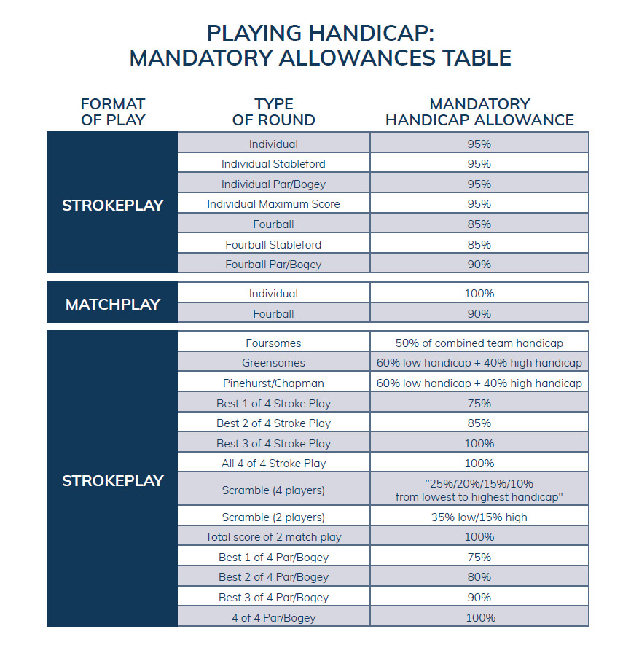

Section 7
READY GOLF PHILOSOPHY – TO IMPROVE THE SPEED OF PLAY
In order to improve the time to play a round of golf and to increase the enjoyment for all competitors here at MVGC we recommend that we adopt a READY GOLF philosophy as follows:
1. TEE SHOTS -There will be no honour, the player ready first plays first, or the shorter hitters play their shots if the longer hitters feel they have to wait. Play off tees to suit your ability - no gender discrimination.
2. Fairway Shots - The first player ready plays if safe to so and not in the way of fellow players again the shorter hitters can play.
3. Assess your next shot as quick as you can and choose your club whilst others are playing their shots.
4.Keep practice swings/strokes to a minimum.
5. Carefully watch shots that are hit off line and shout “Fore” to alert other players.
6. Play your shot before going to help look for another ball.
7. When chipping and putting, play in order of readiness if other players are delayed through bunker raking etc or have a more challenging shot.
8. Do not mark your ball every time it stops on the green if it’s not in the way and putt out even if you are standing close to anotherplayers line.
9.Leave your bag/trolley in a position that will enable quick movement to the next tee.
10.Leave the putting green quickly when the hole is complete.
11. Mark your scorecard on the next tee.
12. Try your best to keep up with the players in front. If you feel you are dropping behind, bring this to the attention of your group and try to speed up. If the position is hopeless and you continue to lose distance on the people in front, let the people behind you through.
SIGNAL PLAYERS IN THE GROUP BEHIND TO PLAY THROUGH WHEN STARTING TO SEARCH FOR A LOST BALL.You are only allowed 3 minutes to look for a ball
17/03/2021

